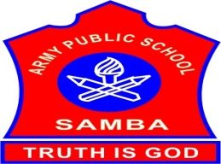
ARMY PUBLIC SCHOOL SAMBA
WEEKLY REPORT
AUGUST 14,2023-AUGUST 19,2023

SCHOOL EVENTS

PTM FOR SLOW LEARNERS (AUGUST 19,2023)
A parent Teacher Meeting for classes I to XII was held on August 19,2023 to discuss the performance of students with their parents. Parents were given feedback regarding the studies and drawbacks of their wards performance in the regular class.In this meeting the teachers and parents discussed about the areas through which they improve their wards’ performance for the best result. It was a great interaction between the teacher and the parents for the development of their children where they discussed both the strengths and areas of improvements. The PTM came to an end with the conclusion that joint effort, mutual understanding and co-operation of parents and teachers is very important for the proper nourishment and progress of students.

INTER HOUSE ENGLISH DEBATE COMPETITION (IX-XII) (AUGUST 18,2023)
An Inter House English Debate Competition was organized for the students of classes IX-XII on August 18,2023 on the topic – “Modern Technology is Destroying Human Social Interaction”.There were three participants from each House, one speaking for the motion, one speaking against the motion and one interjector. All the speakers put forth strong and well-grounded arguments to prove their points,interjectors also raised very logical questions. The speakers answered very confidently, backed with rational examples or instances.The result of the competition is as follows:
Best speakers:
Ishaan Pandey-Teresa House
Navya Sharma-Sarojini House
Best Interjector:
Prerna Jasrotia-Teresa House

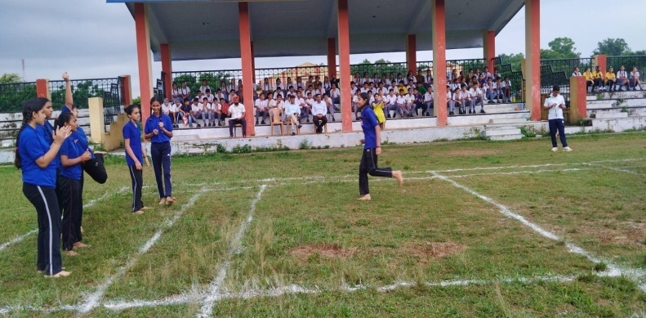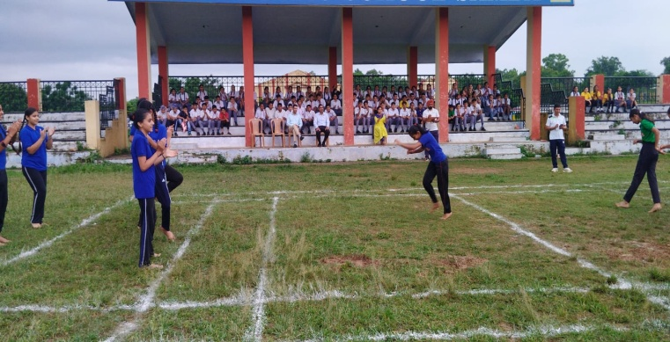

INDEPENDENCE DAY CELEBRATION (AUGUST 15,2023)
On August 15,2023, the patriotic spirit filled the air at APS Samba as the teachers of the school celebrated 77th Independence Day with great enthusiasm.On this occasion a special assembly was organized marking a memorable start to the day. Teachers presented patriotic songs, skit and poem.There was a feeling of pride and patriotism in everyone’s heart. In the end, the Principal addressed the teachers.He told about the supreme sacrifice of the great martyrs who gave their lives for the sake of freedom. He also said that the freedom was very precious and it was very necessary to preserve it.

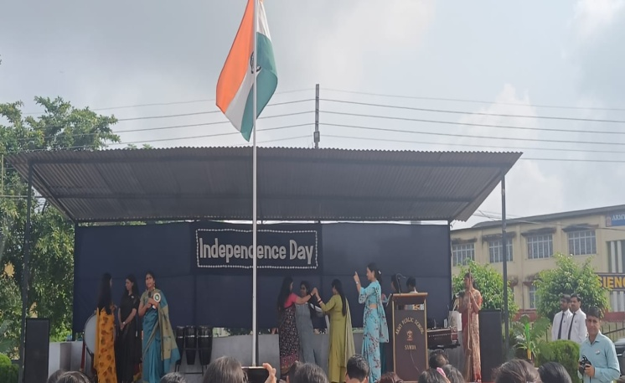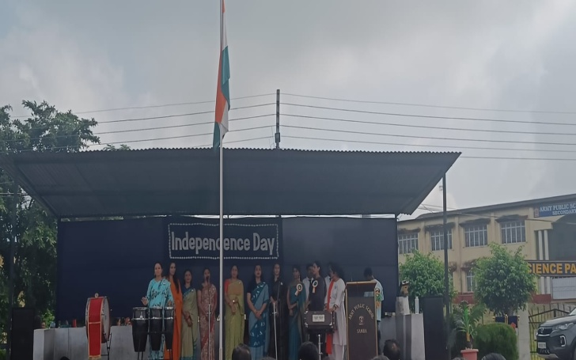
NIAS-ALC OFFLINE SESSION (AUGUST 16,2023)
Offline session of NIAS- ALC was conducted on August 16,2023.The topic of discussion for the class was- “E-waste Management and Plastic Recycling by The Method of Pyrolysis”. Class was fully interactive and students took part in the discussion with great interest.
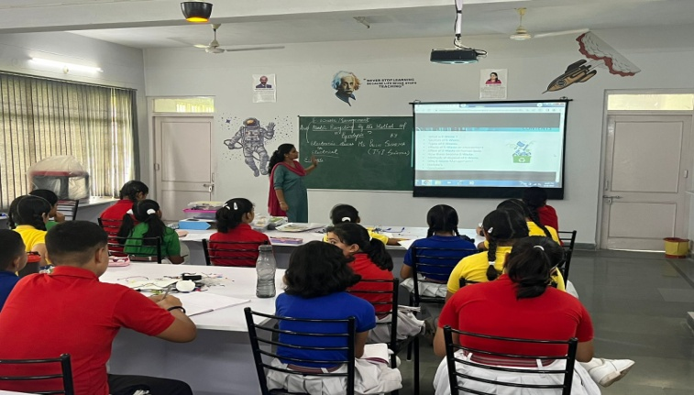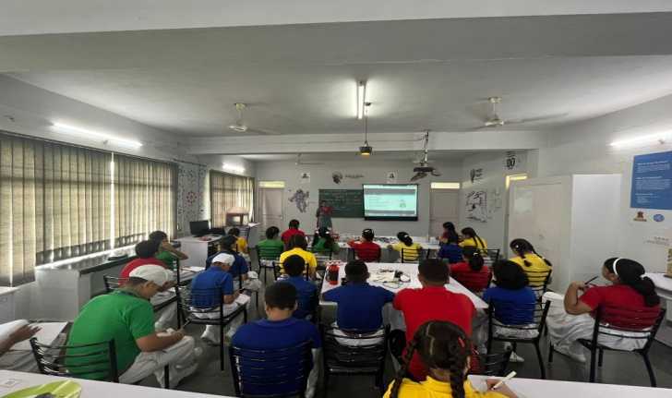

INTER SCHOOL KHO-KHO U-19 (BOYS AND GIRLS) TOURNAMENT (AUGUST 19,2023)
An Inter school Kho-Kho tournament for U-19 boys and girls was organized by DYS Samba on August 19,2023.Team from APS Samba also participated in this tournament.In girls tournament four(4) girls from APS Samba got selected for
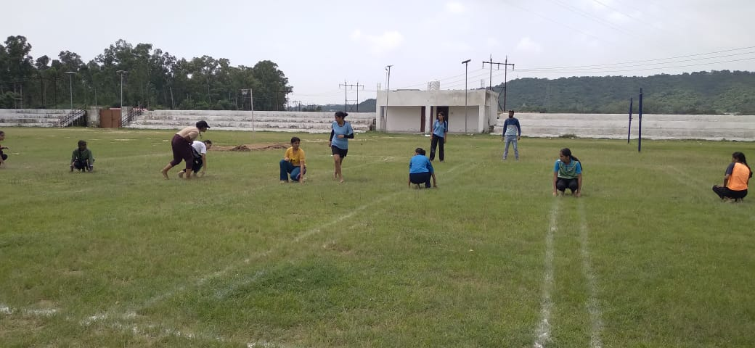
INTER SCHOOL VOLLEYBALL U-19 BOYS TOURNAMENT (AUGUST 19,2023)
An Inter school Volleyball tournament for U-19 boys was organized by DYS Samba on August 19,2023.Team from APS Samba also participated in this tournament.In this tournament four(4) boys from APS Samba got selected for
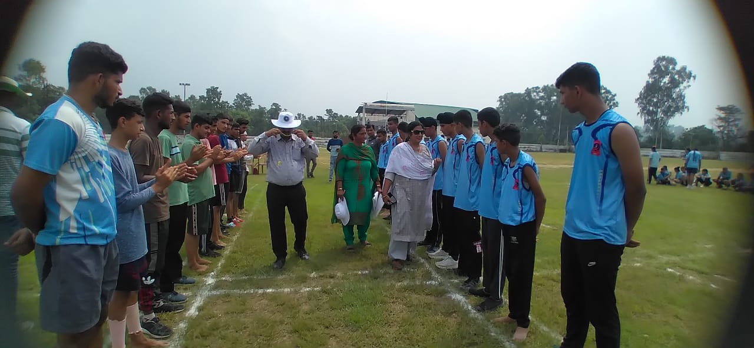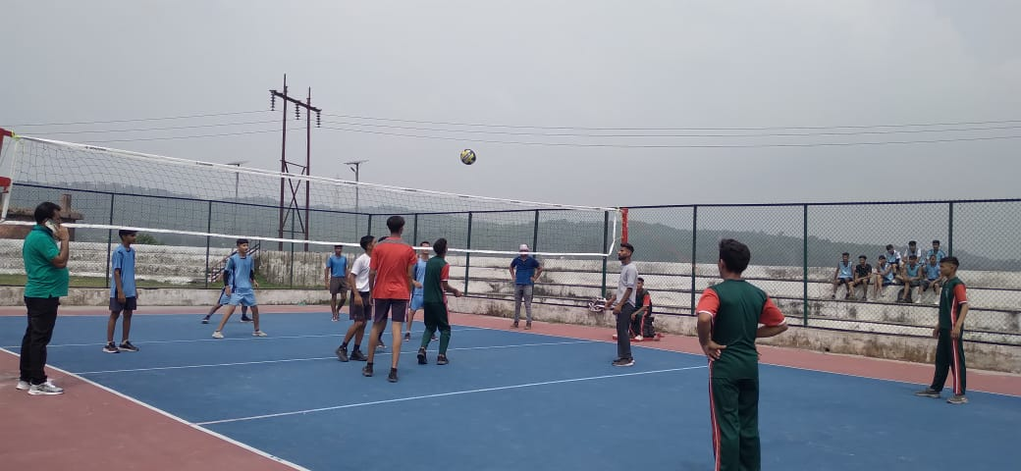

WORKSHOP ON SKILL DEVELOPMENT (18,2023)
Workshop on skill development was conducted by Sh Sandeep Sethi,Ex Education officer CBSE on August18,2023 at MV International School. Following teachers from APS Samba attended the workshop:
1. Ms Tania Sambyal
2. Ms Shilpa
3. Ms Vidhi
4. Mr Rohit
Main highlights of the program were:
1. Graphic Novels and comic books for different subjects on Diksha App
2. Use of Exhibition for teaching
3. Use of theatre in teaching different subjects.
4. Organization of Festivals for teaching
5. CBSE manuals- Skill based learning modules for grade 6,7 and 8.
6. Information about CUET.
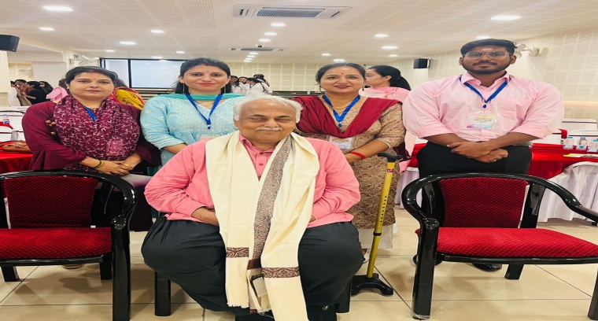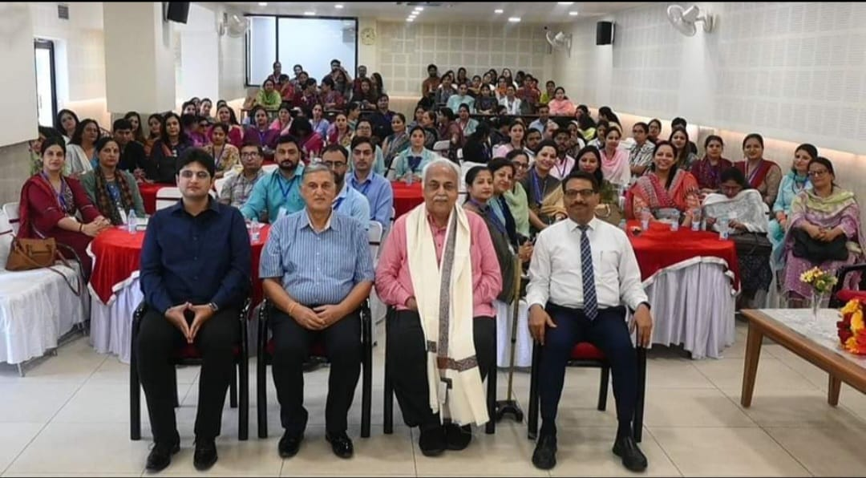
MOTIVATIONAL LECTURE BY COLONEL SHISHIR JUNEJA (AUGUST 14,2023)

With the objective of uplifting the youth, and motivating the students to join the Indian Army, Army Public School Samba organized a motivational talk for students of classes XI and XII in the MP Hall on August 14,2023.Colonel Shishir Juneja was the resource person who spread awareness amongst the students over the aspects regarding employment opportunities being offered by the Indian Army. A total of 200 students attended the lecture and great enthusiasm was noticed among participants including girl participants.During the lecture, various entry schemes and platforms for commission and enrollment in the Army were explained to the aspirants, including mandatory qualification requirements and unparallel pay and perks besides the selection process for various types of entries into the services.In the end,queries of the students were also answered by the resource person.

THANK YOU

